**Nyamata & Ntarama**

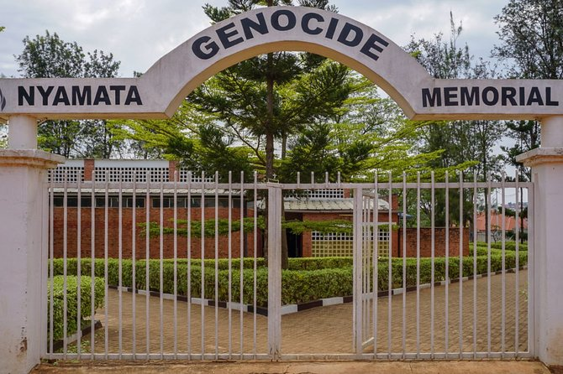Nyamata means ‘place of milk,’ situated to the south of Kigali. During 1994, 10,000 people sought sanctuary in the local church, only to be murdered there. Today, Nyamata church and nearby Ntarama church remain as public memorial sites, housing the remains of around 50,000 people including the body of Roman Catholic Missionary Antonia Locatelli, who was murdered in 1992 for reporting an earlier massacre of Tutsi.

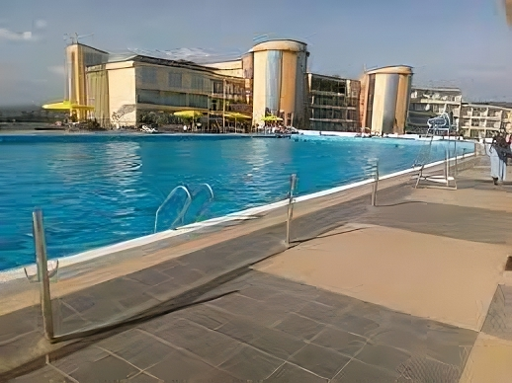Be advised that touring these memorials can be very emotional. There is no fee for entering, but please make a donation to the donation box inside and be mindful when asking questions as many of the guides live locally and witnessed the events of 1994.

As well as historical sites, Nyamata is home to La Palisse Hotel which boasts one of the largest swimming pools in Rwanda. It is a nice place to relax, have a drink and a swim, though it can get very busy during school holidays.

On the road halfway back, between La Palisse and Kigali, there is a turn-off on the right to Bugesera Lodge. Keep your eyes peeled as the sign is small. The lodge has a wonderful garden and shaded restaurant where they serve a five-course French spread, consisting of starter, main course, cheese board, dessert and coffee.

Lunch or dinner can be served at whatever time you choose, but you need to book the day before. WhatsApp lunch bookings to Jocelyne: +250 782 776 930 with any dietary requirements. Lunch/dinner costs $20 per person. The memorials are usually open 8 am – 5 pm with last entry at 4pm.

The main road to Nyamata is paved, but the roads to the memorials and to Bugesera Lodge are mud tracks that are not always well maintained. Be prepared for a little light off-roading.